From OBIT, by Victoria Chang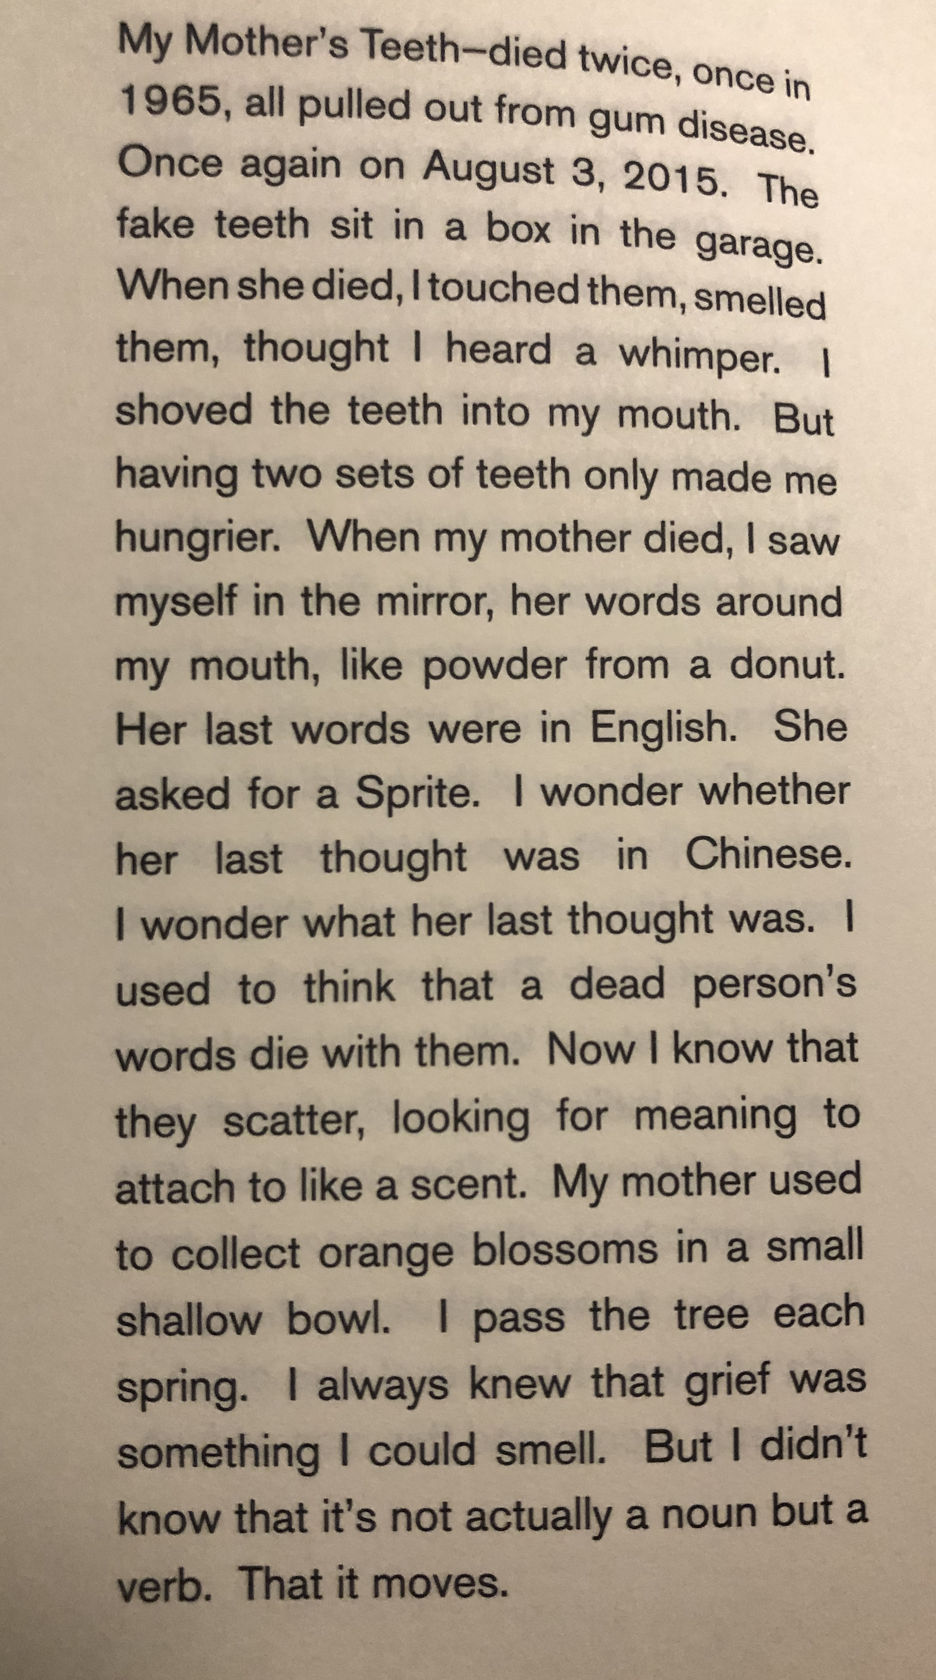

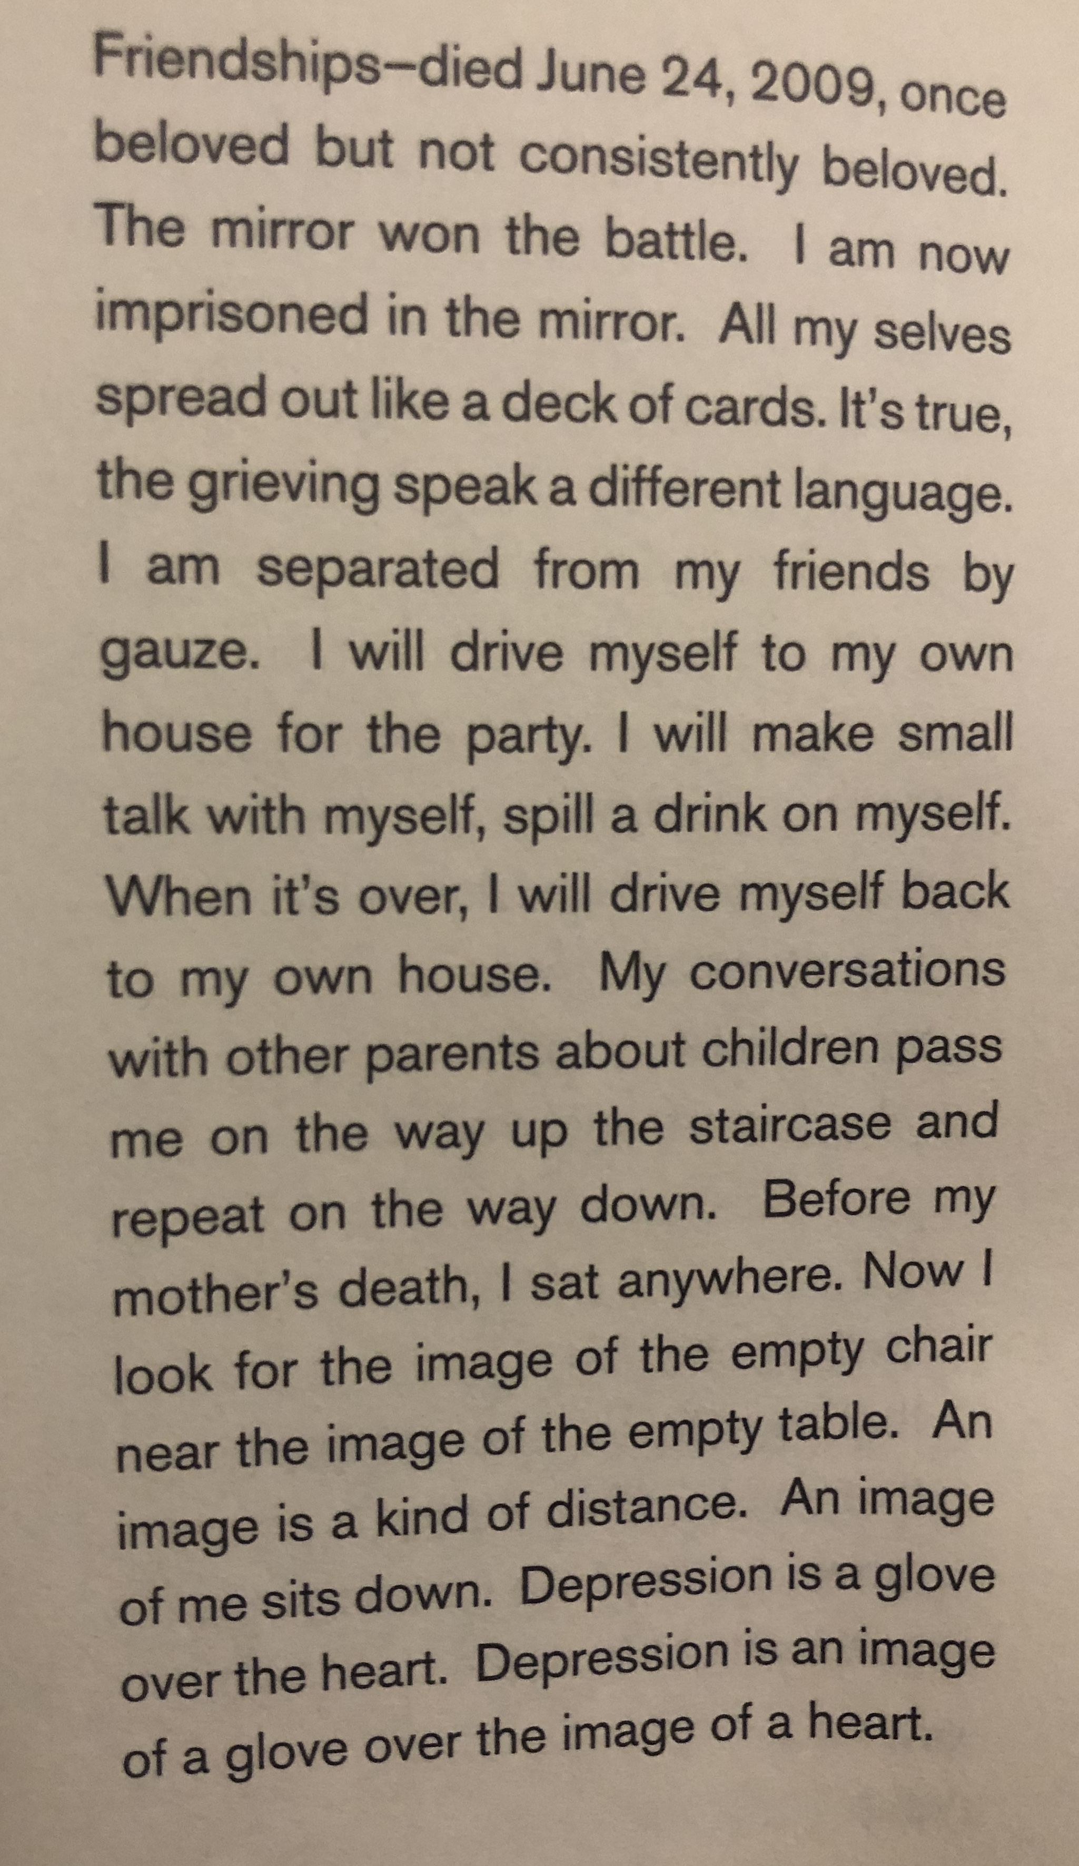

From To the Lighthouse, by Virginia Woolf
The nights now are full of wind and destruction; the trees plunge and bend and their leaves fly helter skelter until the lawn is plastered with them and they lie packed in gutters and choke rain pipes and scatter damp paths. Also the sea tosses itself and breaks itself, and should any sleeper fancying that he might find on the beach an answer to his doubts, a sharer of his solitude, throw off his bedclothes and go down by himself to walk on the sand, no image with semblance of serving and divine promptitude comes readily to hand bringing the night to order and making the world reflect the compass of the soul. The hand dwindles in his hand; the voice bellows in his ear. Almost it would appear that it is useless in such confusion to ask the night those questions as to what, and why, and wherefore, which tempt the sleeper from his bed to seek an answer.
[Mr. Ramsay, stumbling along a passage one dark morning, stretched his arms out, but Mrs. Ramsay having died rather suddenly the night before, his arms, though stretched out, remained empty.]

(later)
So loveliness reigned and stillness, and together made the shape of loveliness itself, a form from which life had parted; solitary like a pool at evening, far distant, seen from a train window, vanishing so quickly that the pool, pale in the evening, is scarcely robbed of its solitude, though once seen. Loveliness and stillness clasped hands in the bedroom, and among the shrouded jugs and sheeted chairs even the prying of the wind, and the soft nose of the clammy sea airs, rubbing, snuffling, iterating, and reiterating their questions—"Will you fade? Will you perish?"—scarcely disturbed the peace, the indifference, the air of pure integrity, as if the question they asked scarcely needed that they should answer: we remain.

From The Death of Ivan Ilyich, by Leo Tolstoy

